**Steps of SCCM/Microsoft Configuration Manager**

Microsoft Configuration Manager is a **systems management** software product developed by Microsoft for managing large groups of computers. Microsoft Configuration Manager helps IT admins **deploy**, **manage**, **secure**, and **monitor** devices and software across an organization.

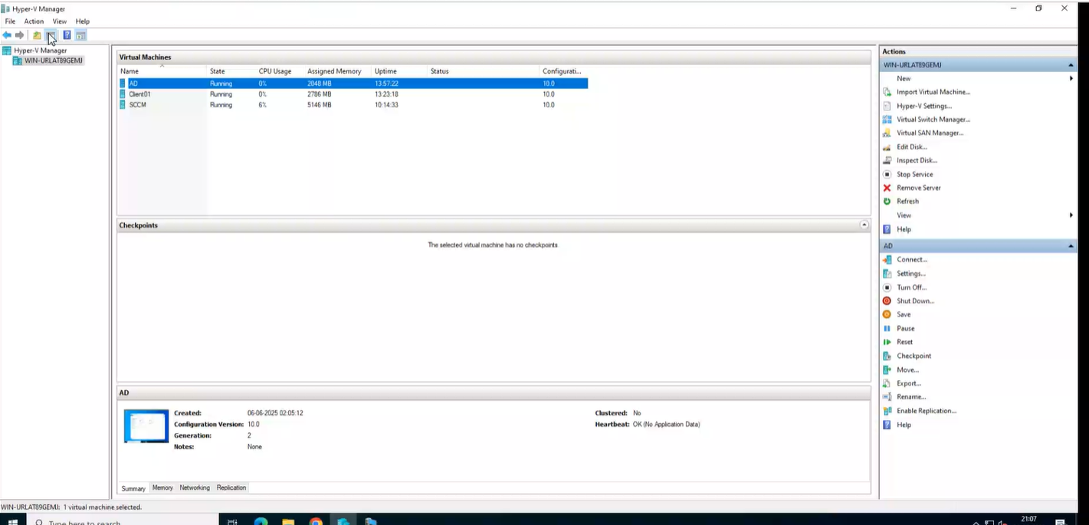**Step 1:** Open **Hyper-V Manager** -> Click on **WIN-URLAT89GEMJ** (username)

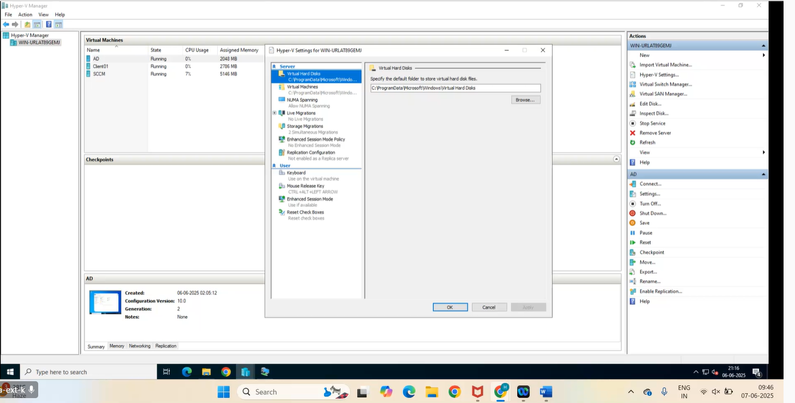**Step 2:** Click on **Hyper-V Setting** (from the right pane)

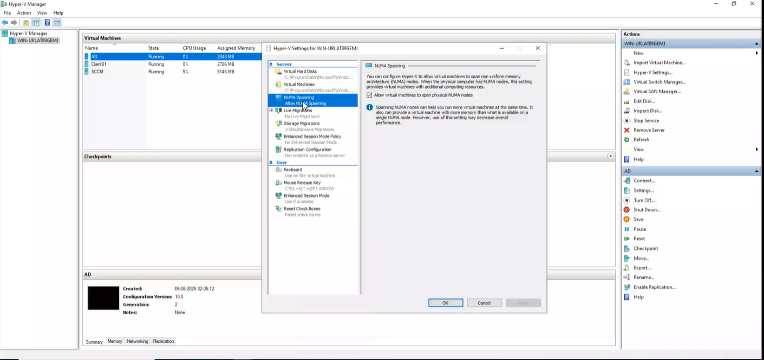**Step 3:** In Hyper-V setting ->in server **NUMA Spanning** in that we have a check box that indicates that the virtual machine can be of variable sizes [Here the virtual machine AD, SCCM have different Assigned memory because of the span size]

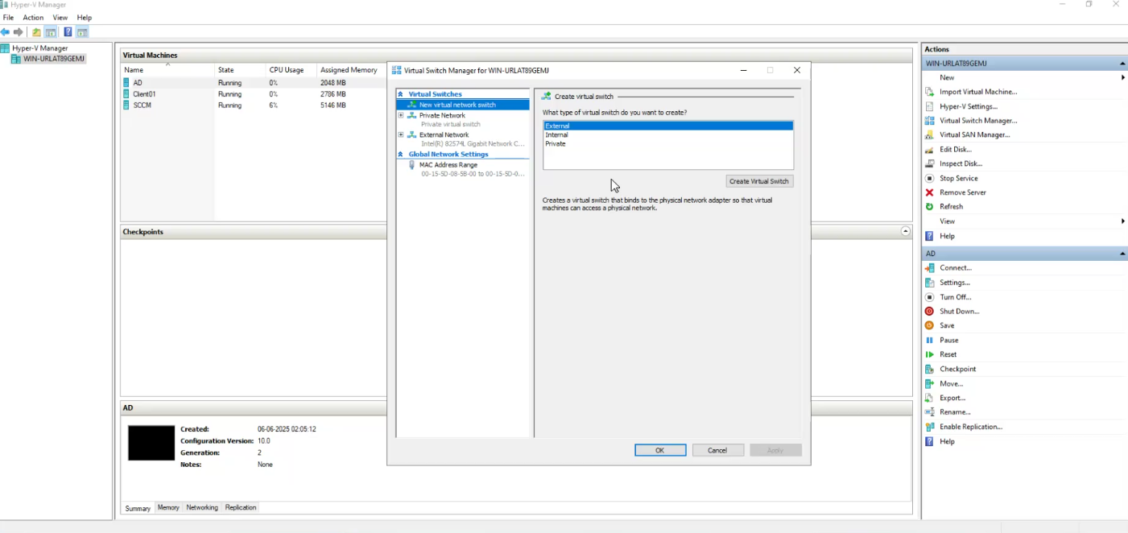**Step 4:** In **Virtual Switch Manager**->and check the details in **new virtual network switch** -> select External

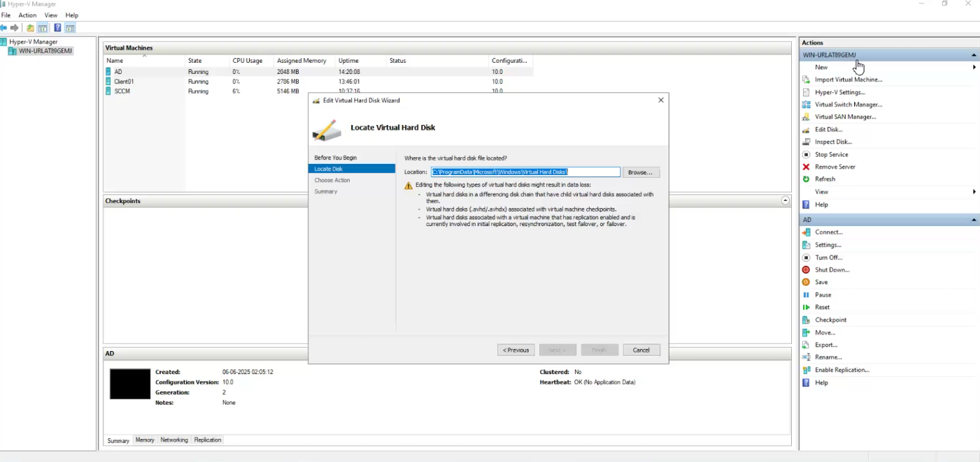**Step 5:** Click on **Edit Disk** on the right pane it opens Edit Virtual Hard Disk Wizard and check the details

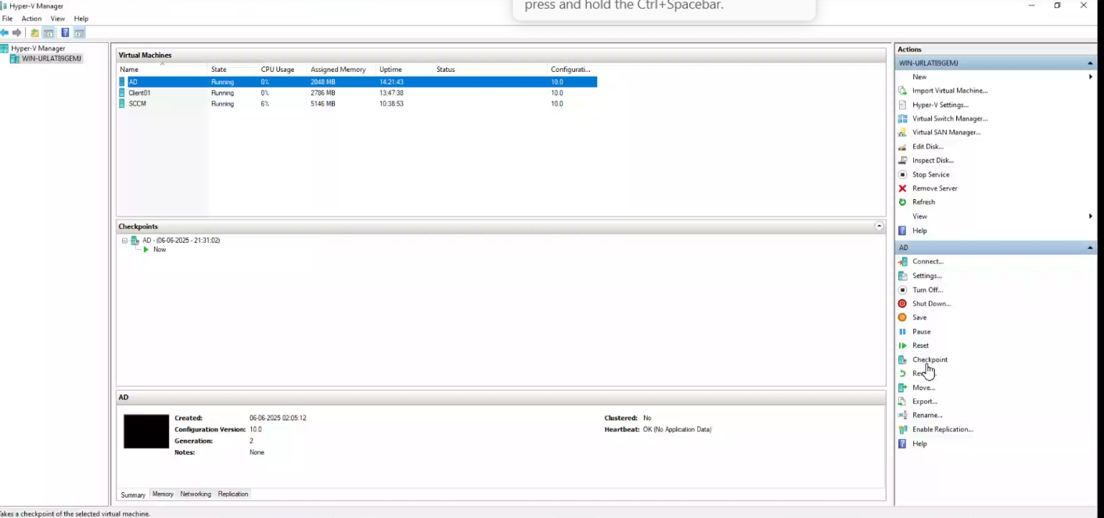**Step 6:** Click on **AD** and click on **checkpoint** it will create a current checkpoint as shown in the below image

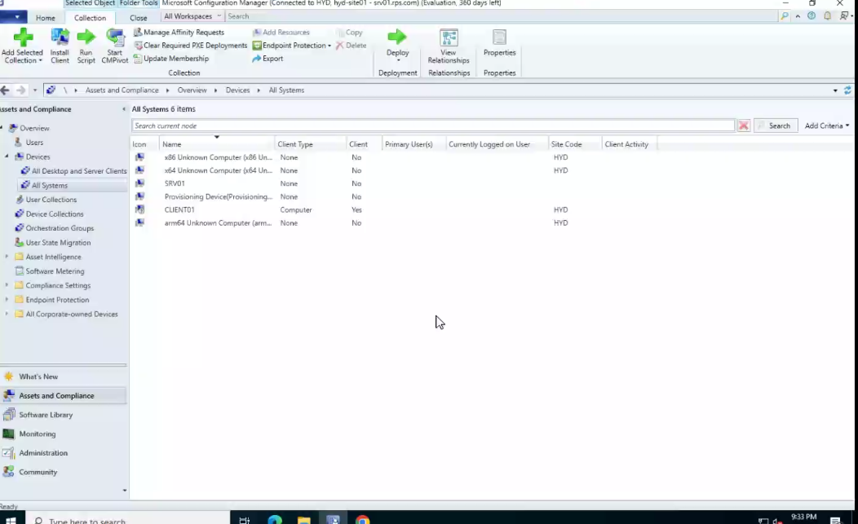**Step 7:** Next, click on **AD** (right-side panel) and click on **Connect** then **Configuration Manager Console (SCCM on WIN_URLAT89GEMJ)** application opens. Have a

**Step 8:** Click on **Users** to check if any users are available or not.

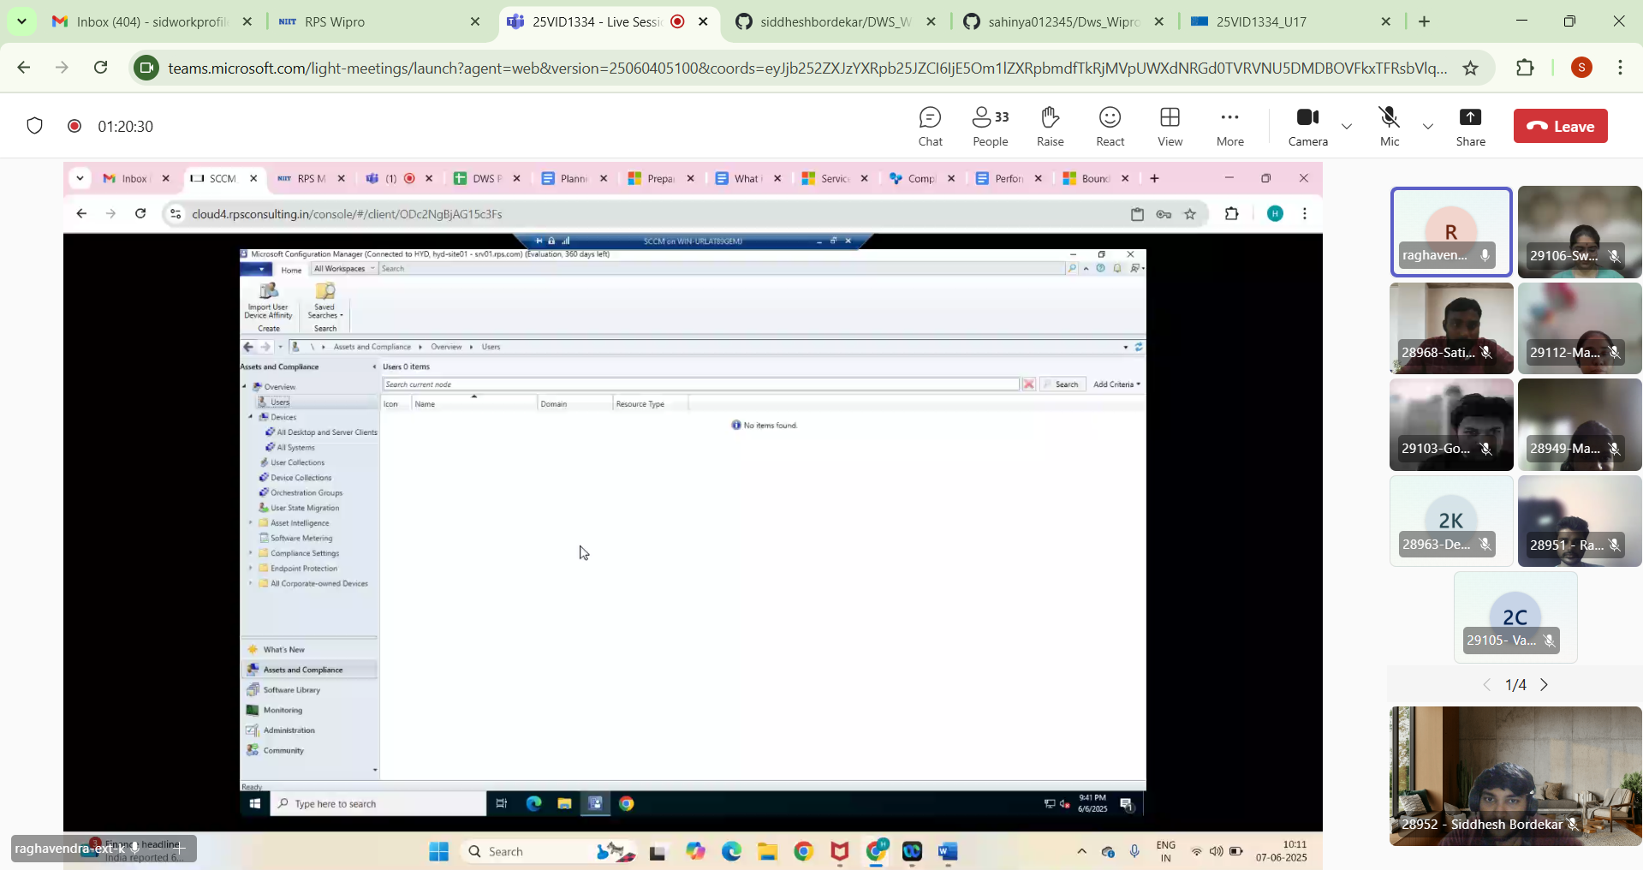

**Step 9:** Click on All Desktop and Server Clients and check the clients available.

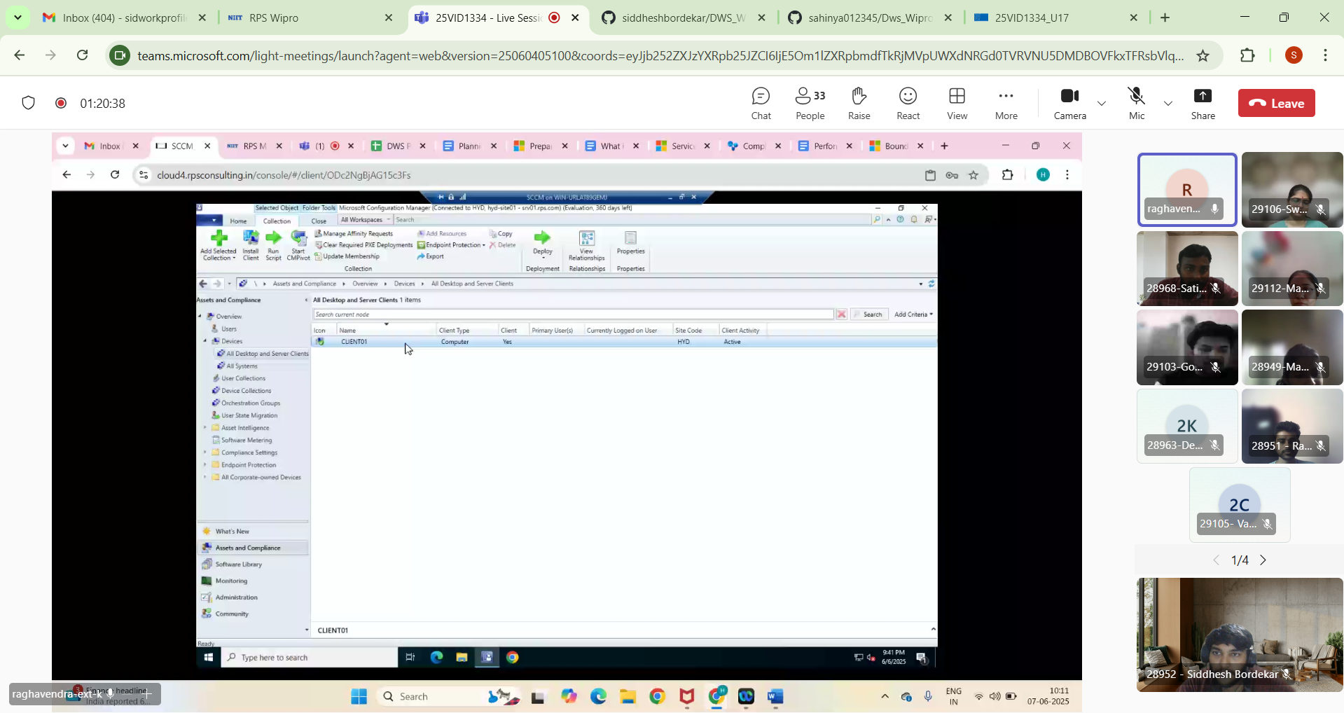

**Step 10:** Click on **Add Selected Items** then click on **Add Selected Items to Existing User Collection** which would add **Devices**.

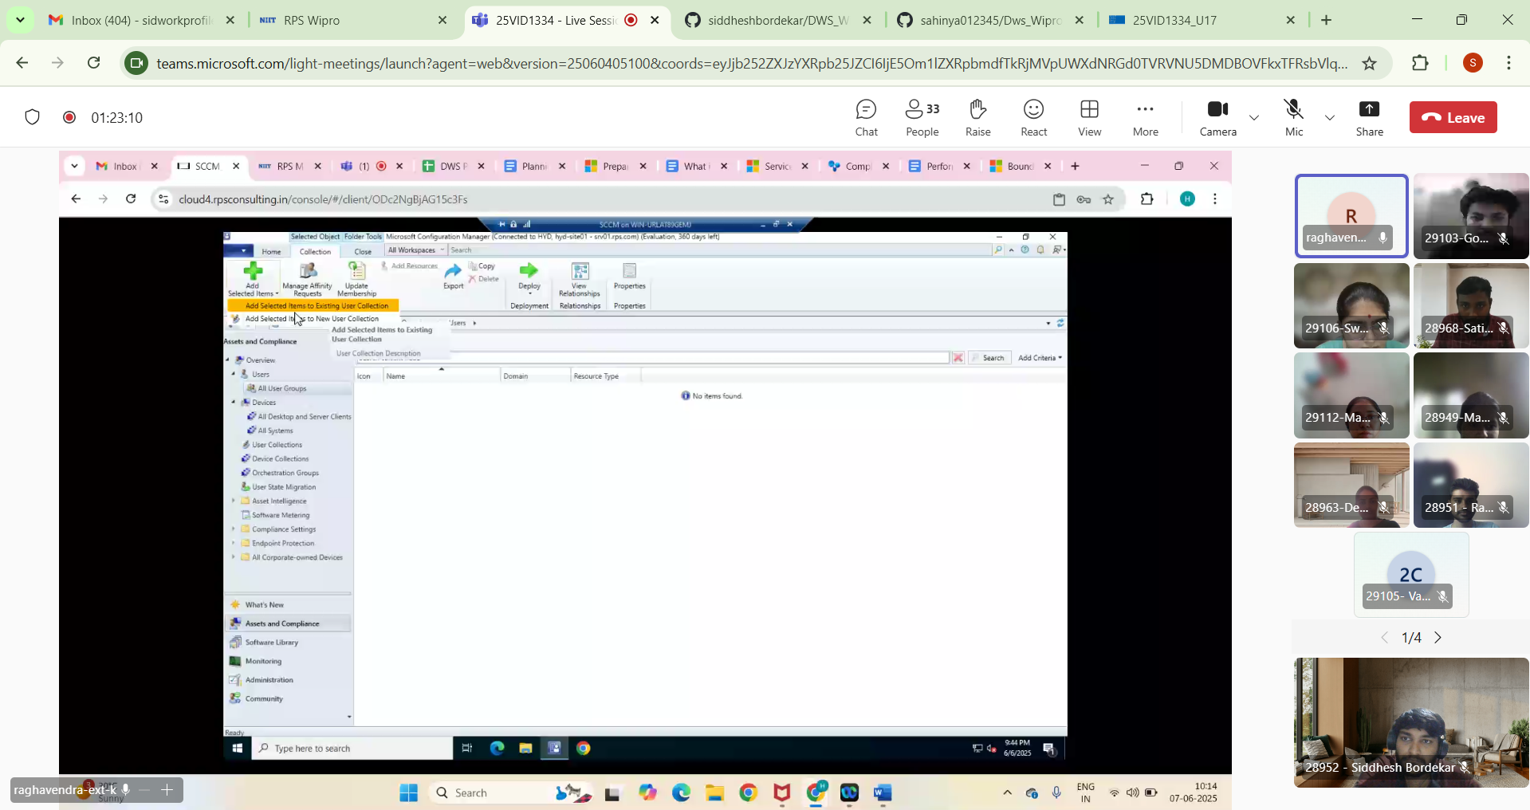

**Step 11:**  Click on **Device Collections** and check the devices available.

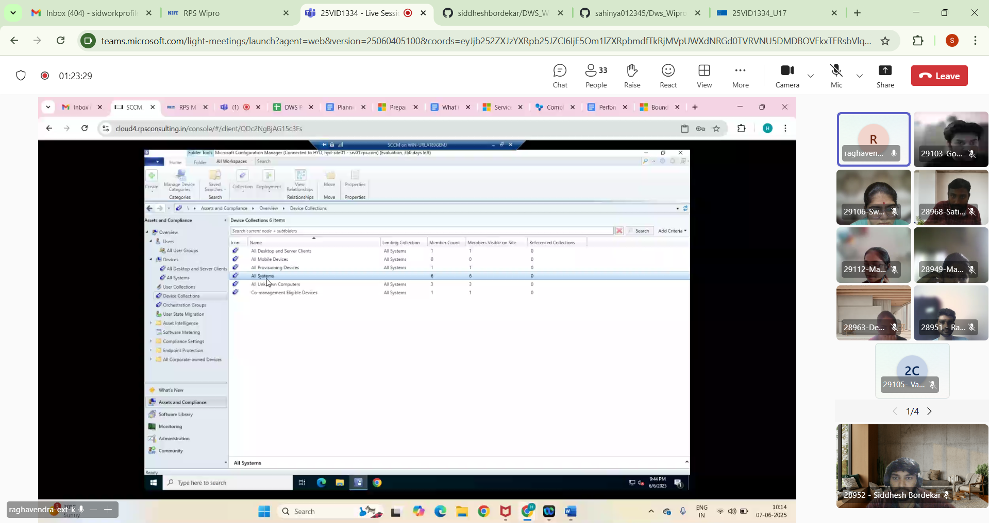

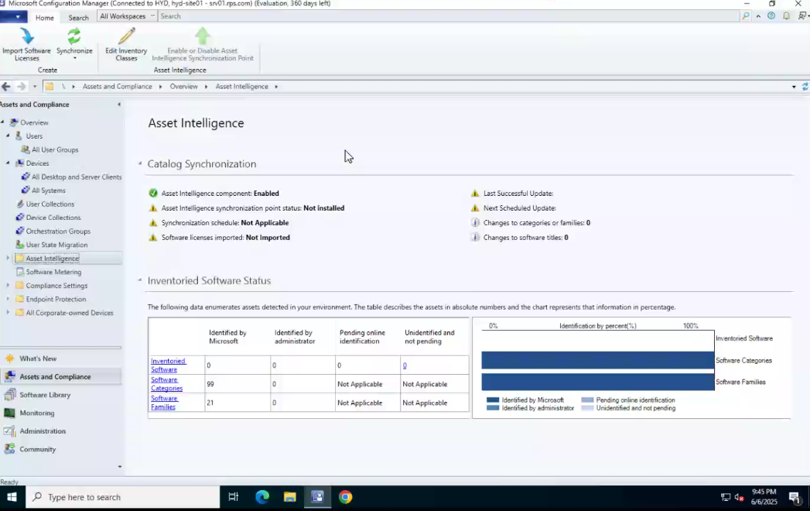**Step 12:** Check **Asset Intelligence** and check the details of **Catalog Synchronization** and **Inventoried Software Status**.

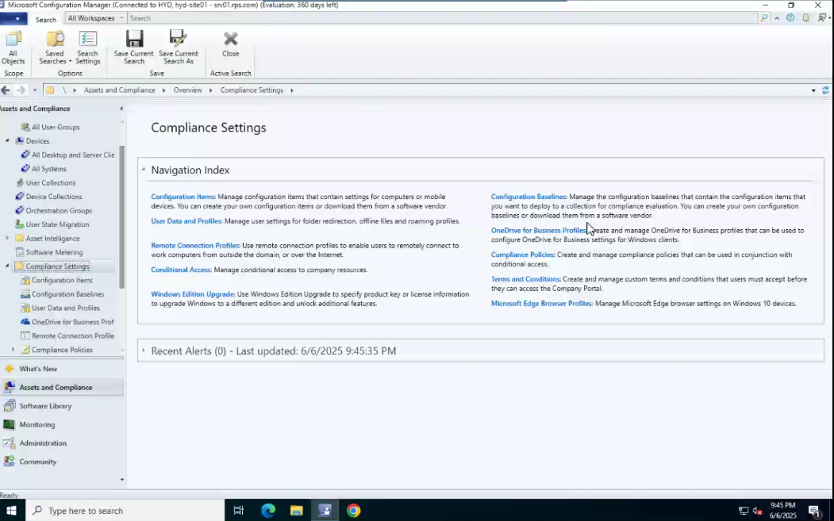**Step 13:** Here **Compliance Settings** ensure computers comply with security configurations (e.g: Configuration Items)

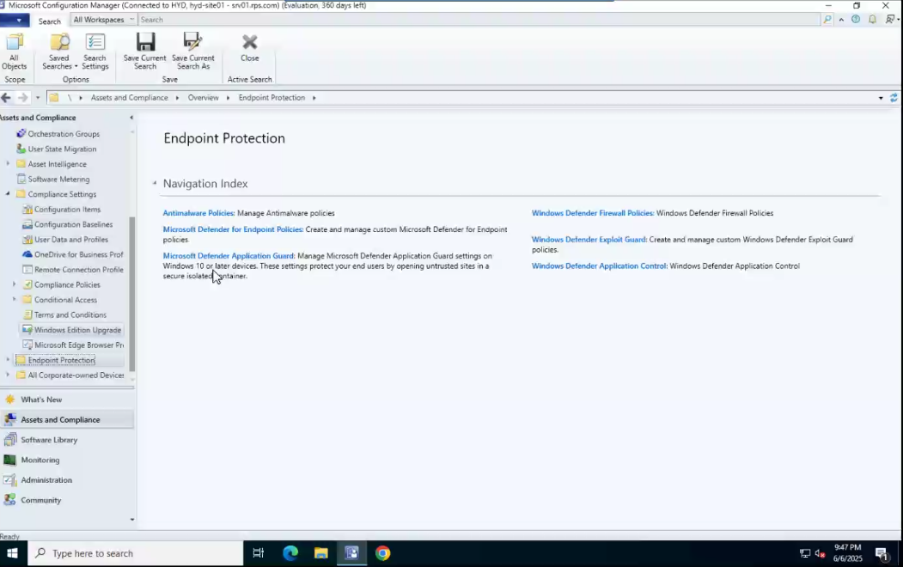**Step 14:** Here are the **Endpoint Protection** and it **Integrate** with antivirus and anti-malware policies (e.g: Microsoft Defender for Endpoint Policies, Windows Defender).

**Step 15:** In **Adminstration**->In Distribution points the **distribution points** are located.

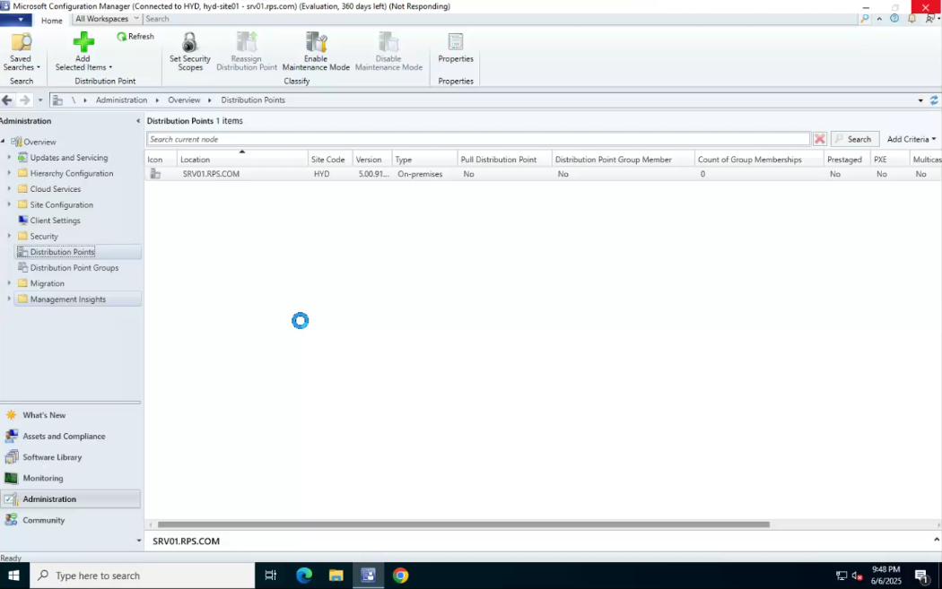

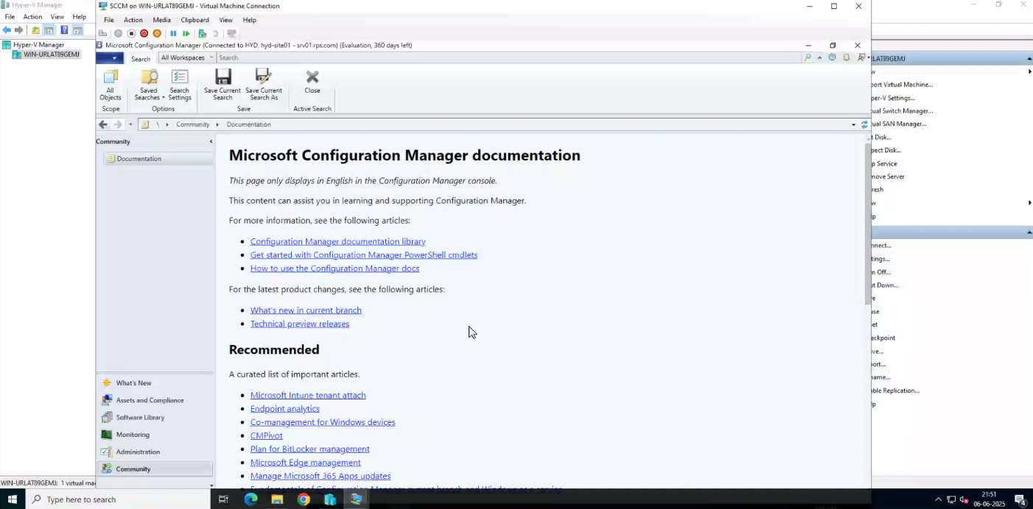**Step 16:** This is the **Community**(at the bottom left corner) here the documents are present

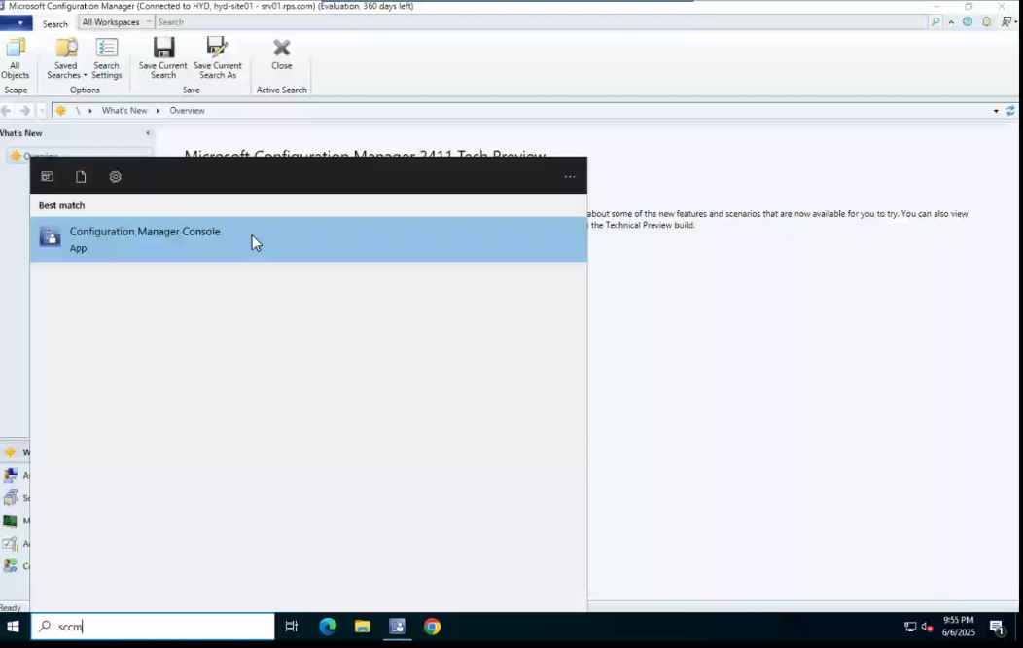**Step 17:** Another way to open **Configuration manager console**-> simply search in Start Menu and open it.

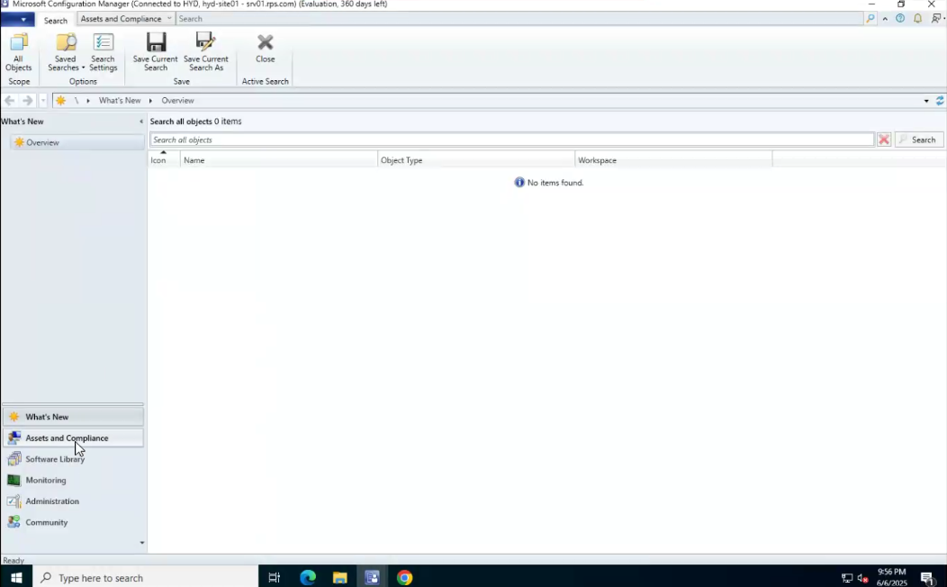**Step 18:** This **is Configuration manager** then select Assets and Compliance,Administration,etc

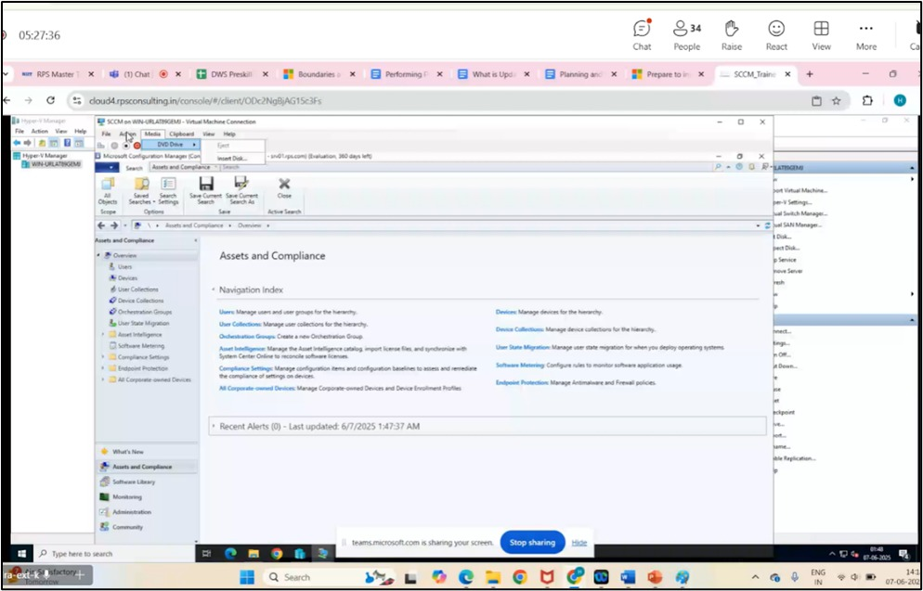**Step 1:** Open -> SCCM virtual machine -> In **Assets and Compliance** which is present at the bottom left corner check the details

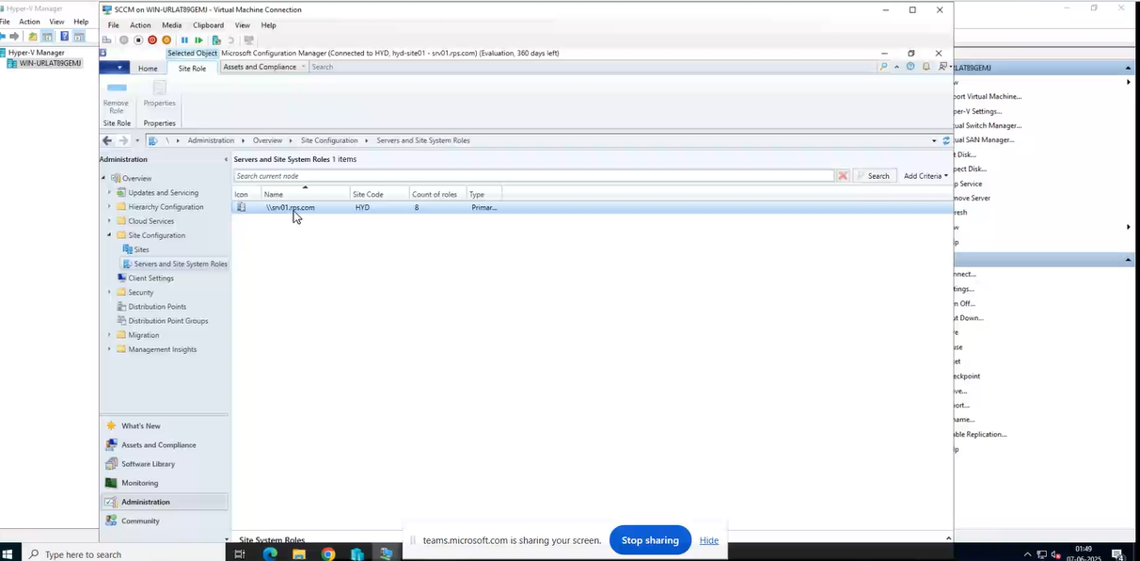**Step 2:** In Site Configuration -> Server and Site System Roles -> srv01.rps.com this is the Primary server

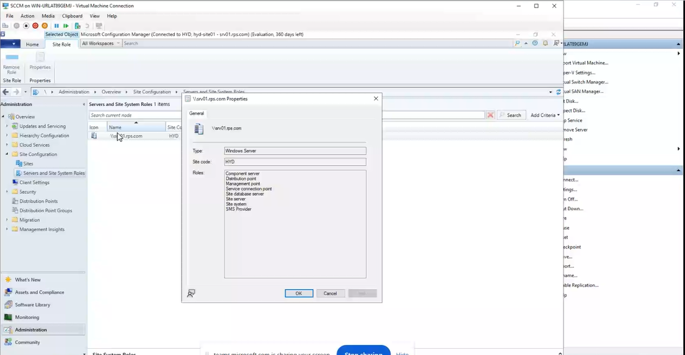**Step 3:** Open srv01.rps.com Properties check the details

**Step 4:** Inside **Site Configuration** click on Sites and check the available site

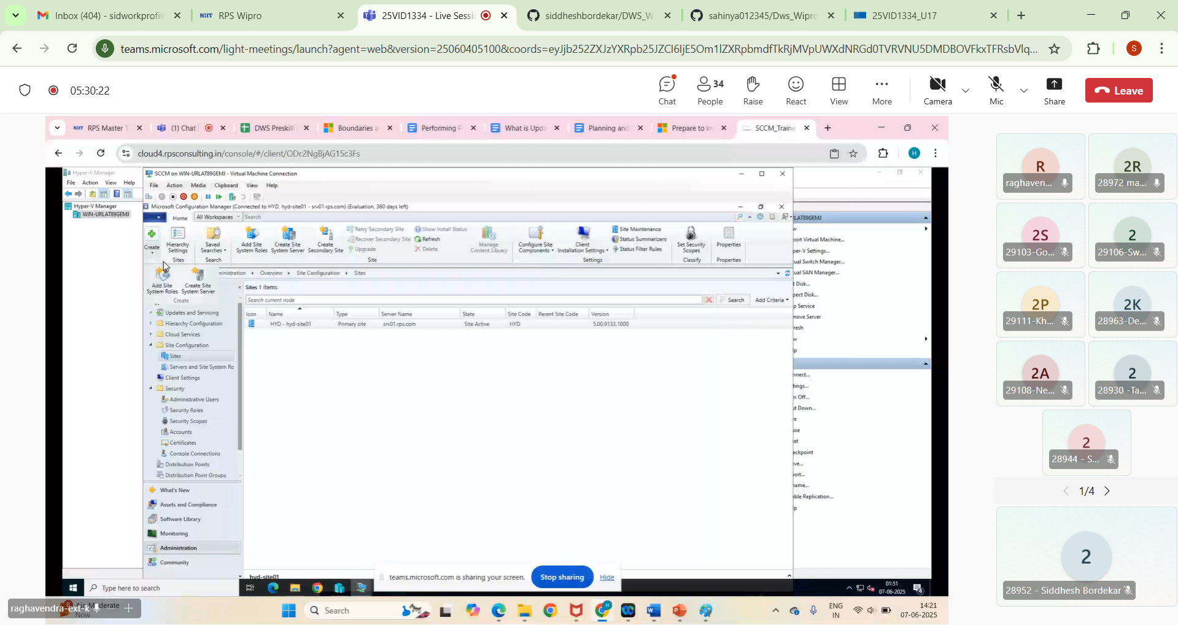

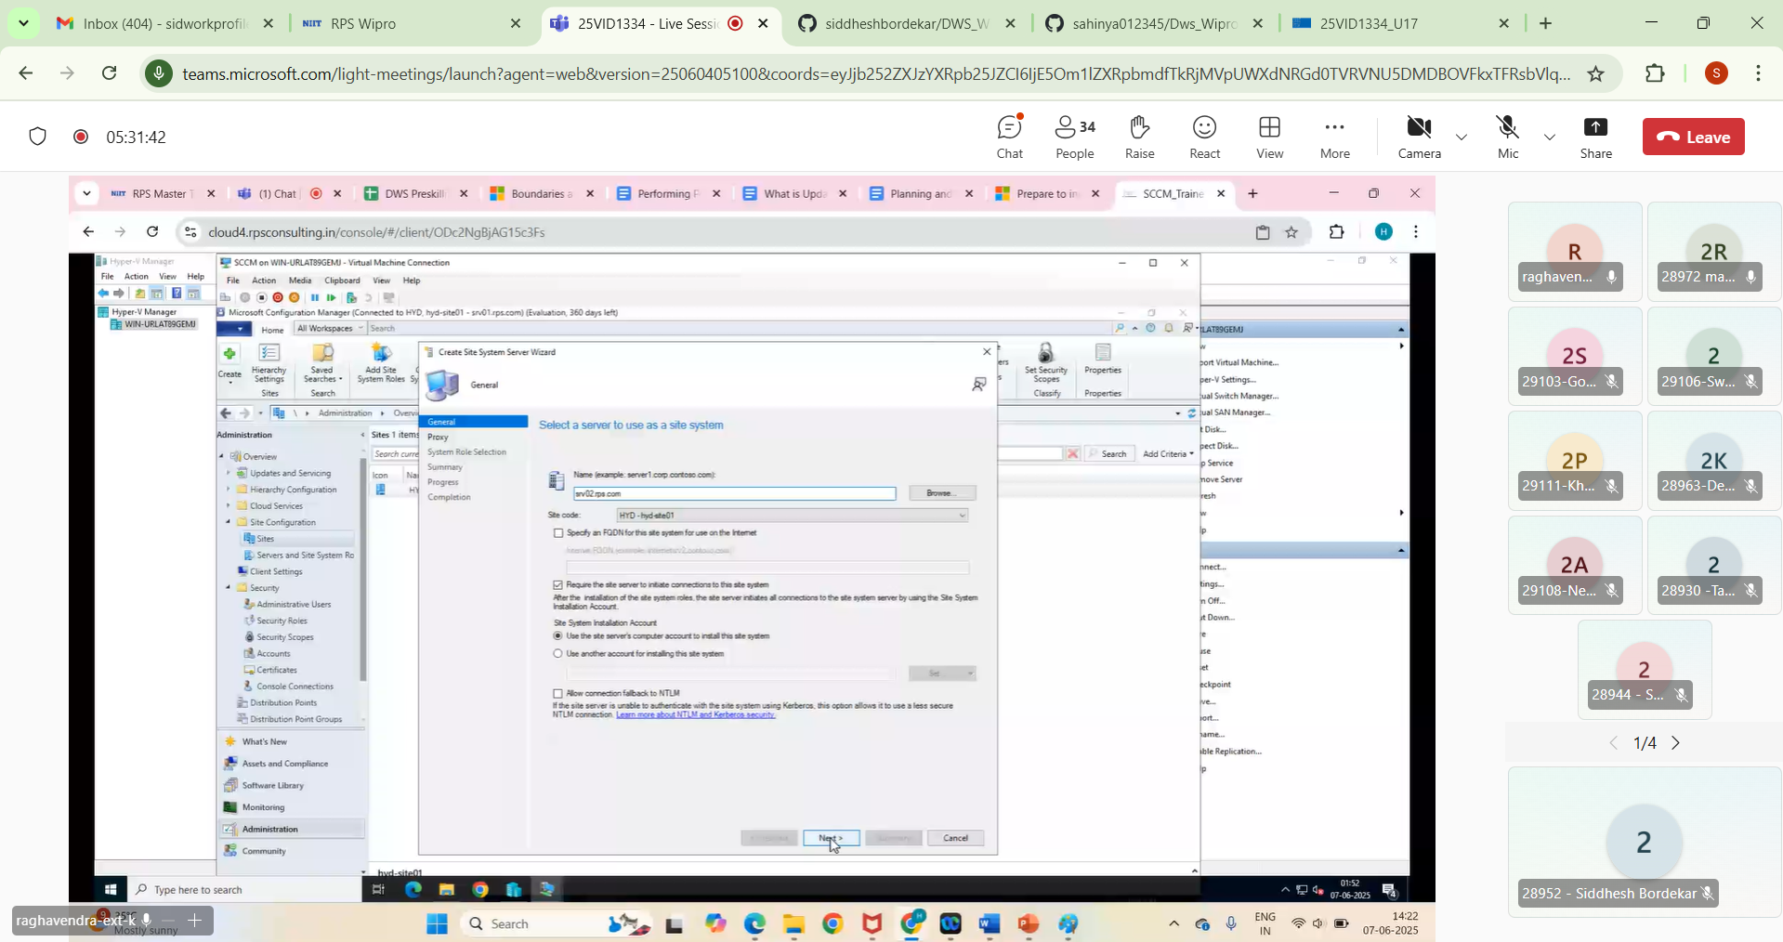**Step 5:** Click on **Create** (top-left above panel) then In **General** in name textbox write **srv02.rps.com** and click on checkbox **Require the site server to initiate corrections to this site system** -> **Next**

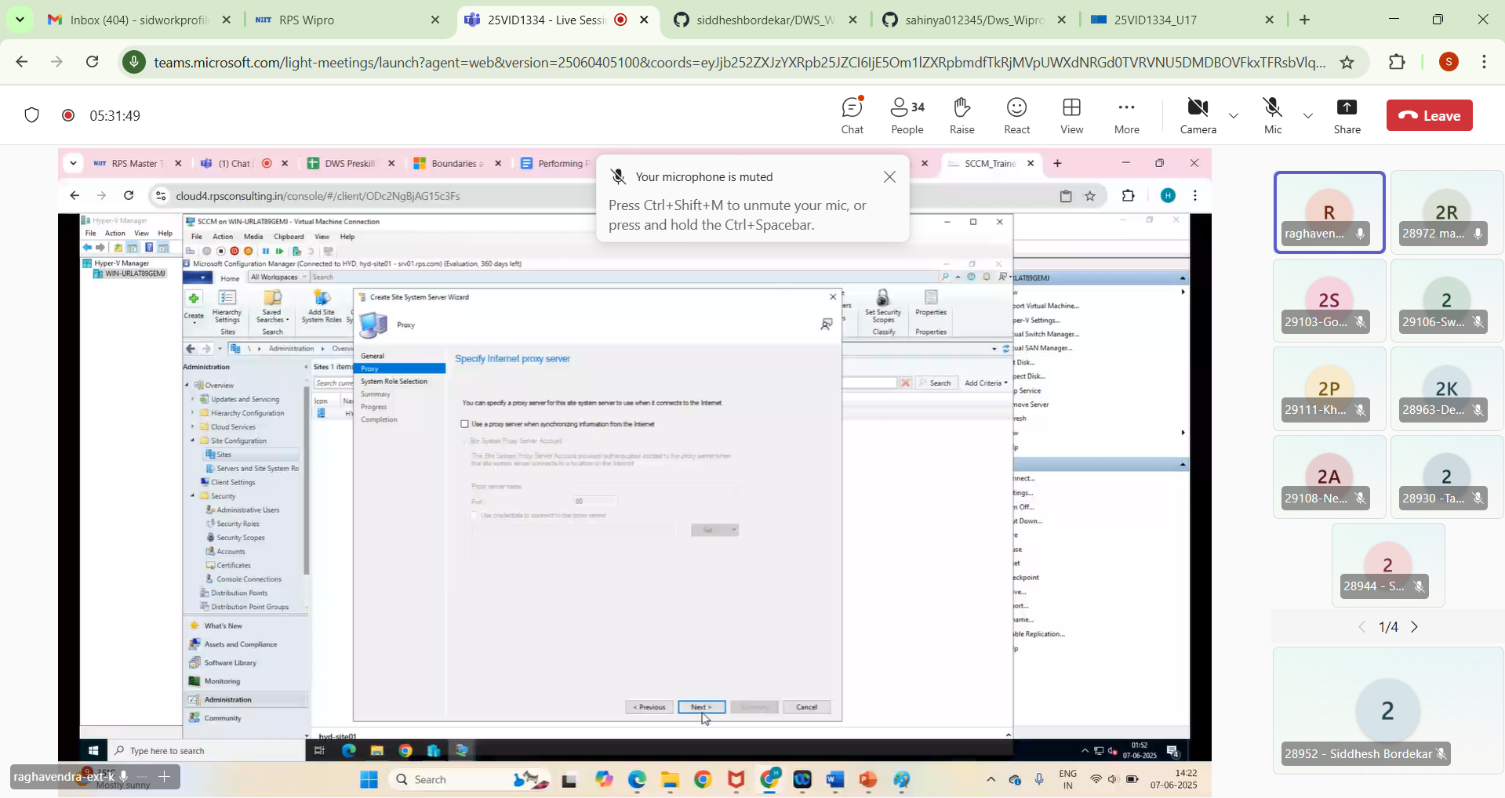**Step 6: In Proxy tab** do nothing and click **Next**.

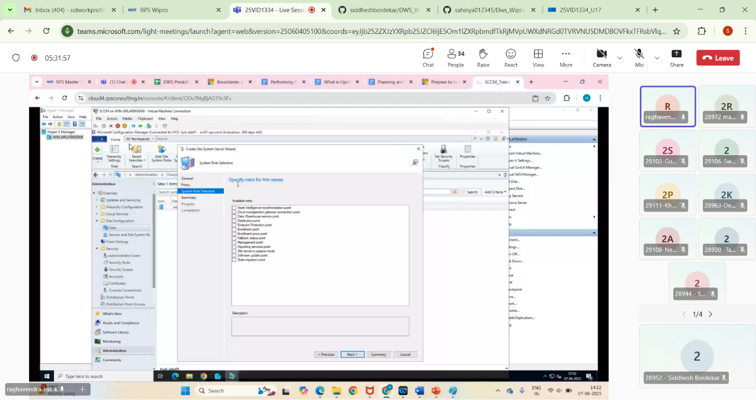**Step 7:** In **System Role Selection** tab select some roles if we want to otherwise directly click **Next**.

**Step 8:** In **Summary** tab do nothing and click **Next**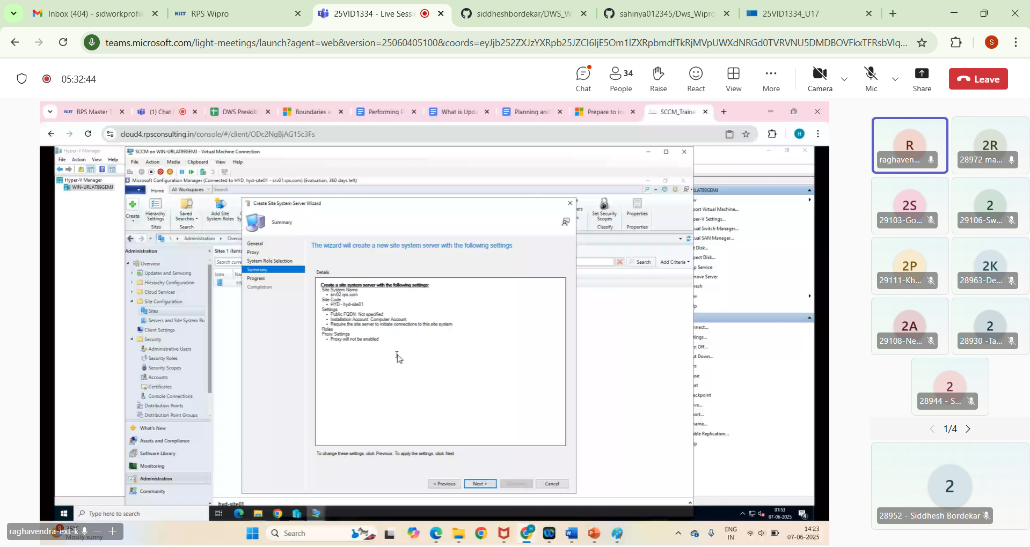

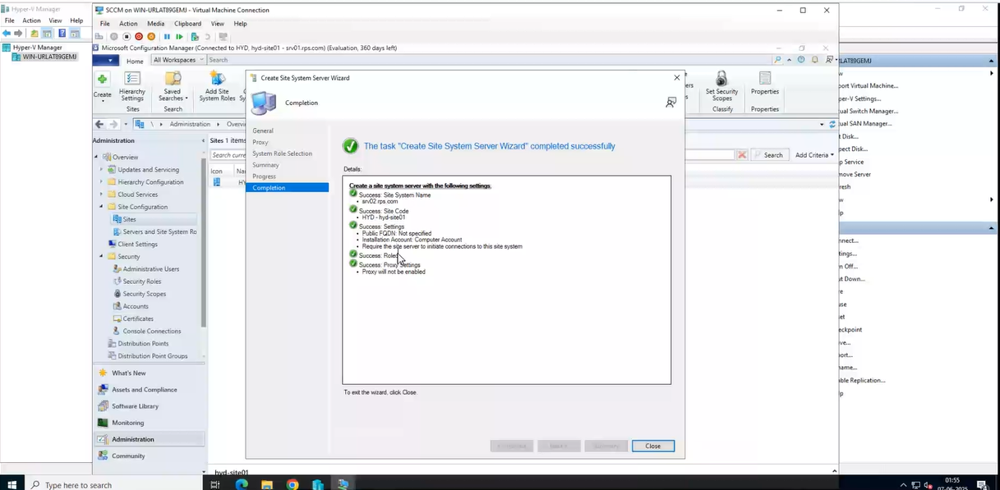**Step 9:** In **Programs tab** -> **Next** -> and In **Completion tab** -> It will show success and close the window.

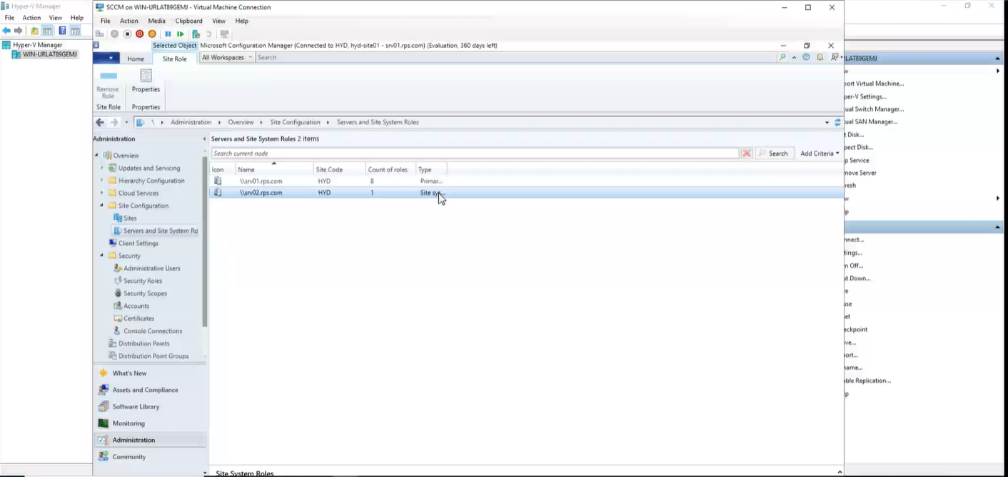**Step 10:** Again navigate to **Servers and Site System Roles** and check if the site is created or not.

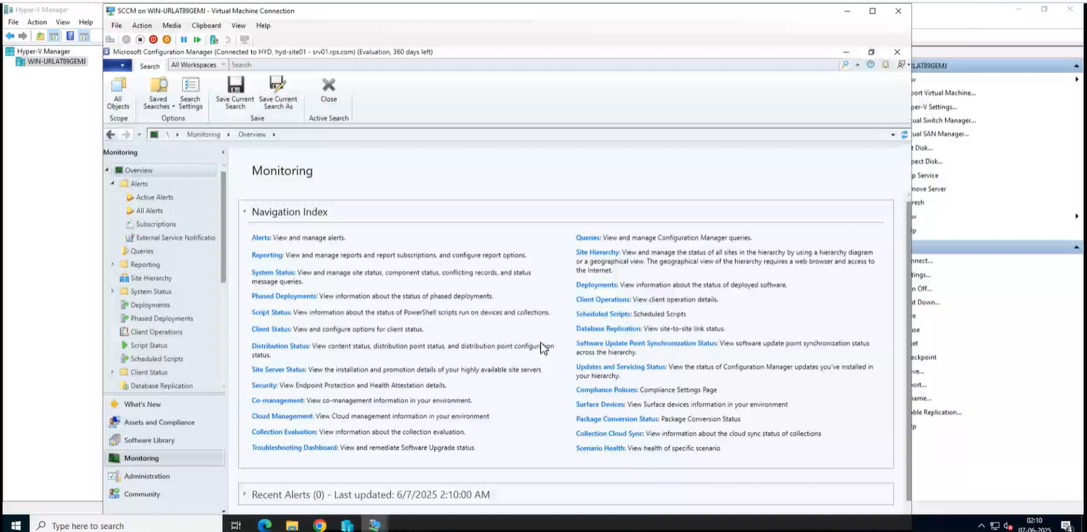**Step 11:** Click on **Monitoring** (bottom-left panel) and check the details of **Navigation Index** and also navigate to **Alerts, System Status, Script Status, Client Status,** and review them.

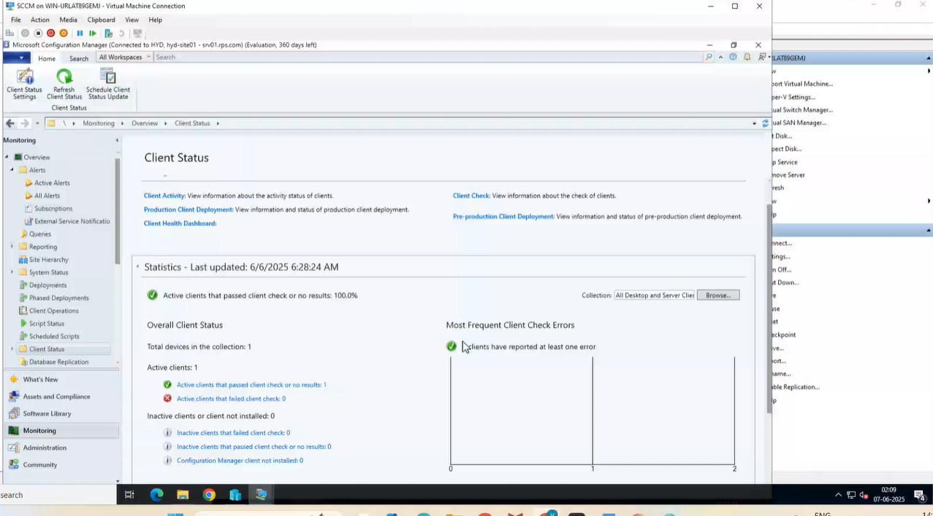

**Managing the Configuration Manager client involves several key areas**

* **Discovery and Deployment:**

**Discovery**: SCCM uses **build-in methods** like Active Directory Discovery to **locate devices** in your network **that don't have the client installed**.

**Deployment:** Install the client software using various methods, including **client push installation,** **software update-based installation**, **Group Policy, manual installation**, etc.

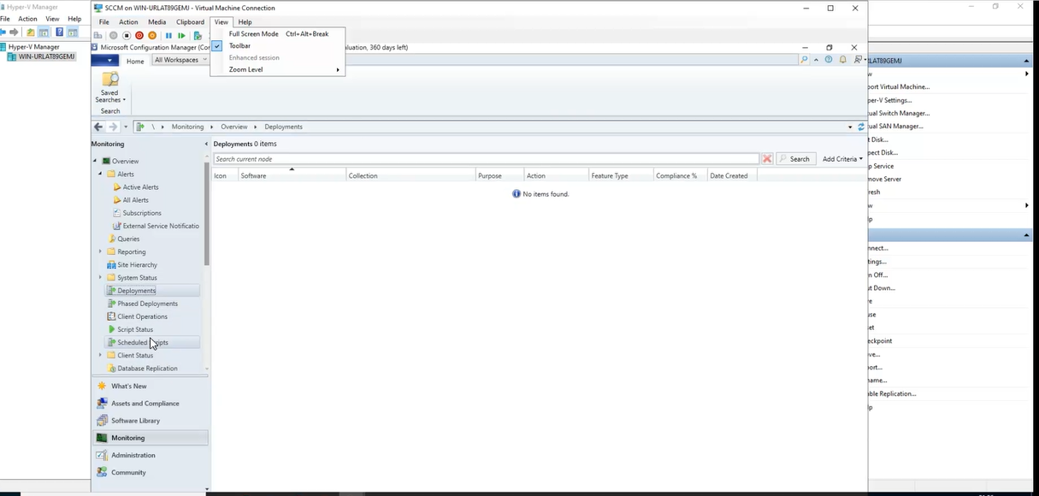**Deployment:**

* **Configuring Client Settings**

**Access**: Manage all client settings through the Client Settings node (in the Administration)

**Default vs. Custom**: Default settings (apply to all clients), Custom settings (targeted to specific collections).

**Client Settings:** Includes Software Updates, Client Activity, and Client Check, to manage client behavior and compliance.

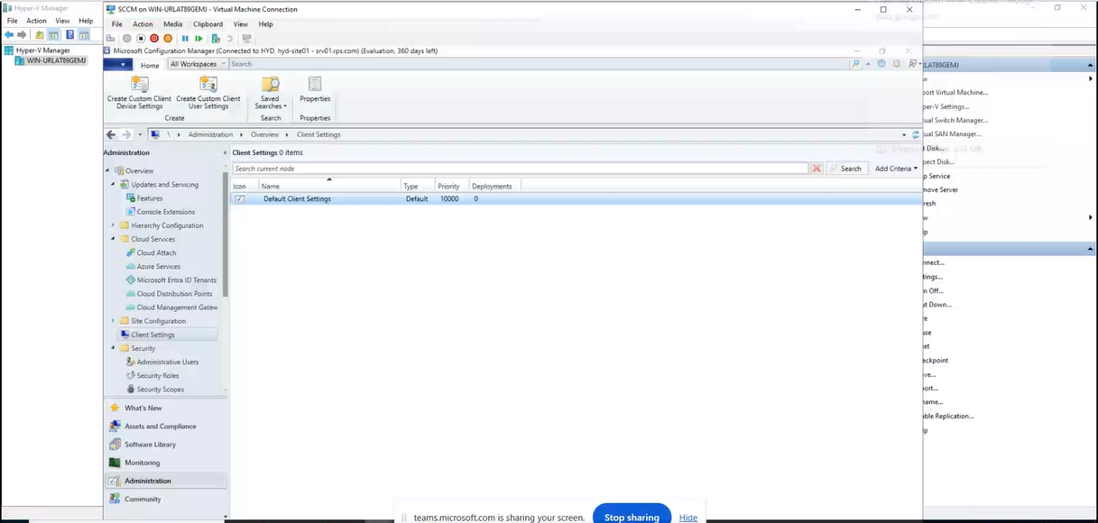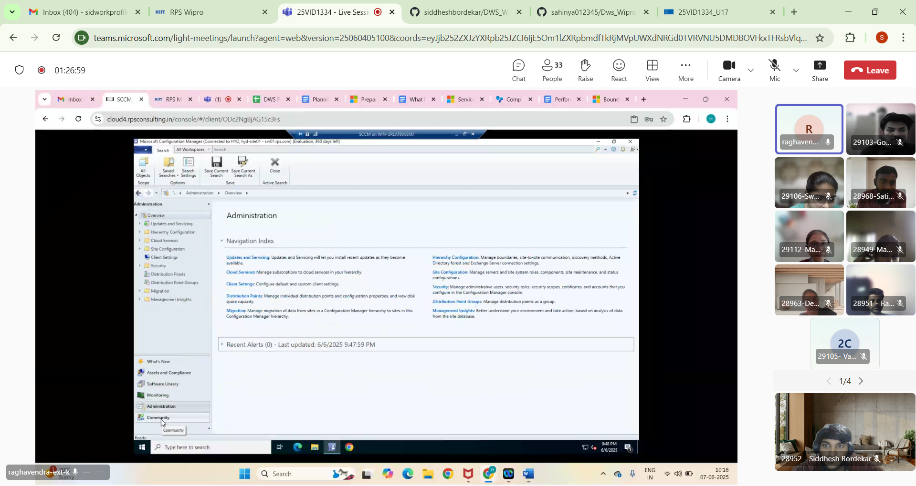**Client Settings:**

* **Managing the Client Cache**

The client cache stores files needed for deployments, like software updates and packages.

Manage the space used to temporarily store downloaded files on the client.

The **client cache** stores: Software packages, Updates, Scripts and also we can use "Delete Files" option in the control panel to remove files in the cache when needed.

* **Monitoring Client Status**

**In Monitoring we check the** status, View health, and alerts for all clients.

**Alerts** can notify you if a certain percentage of clients go inactive or fail health checks

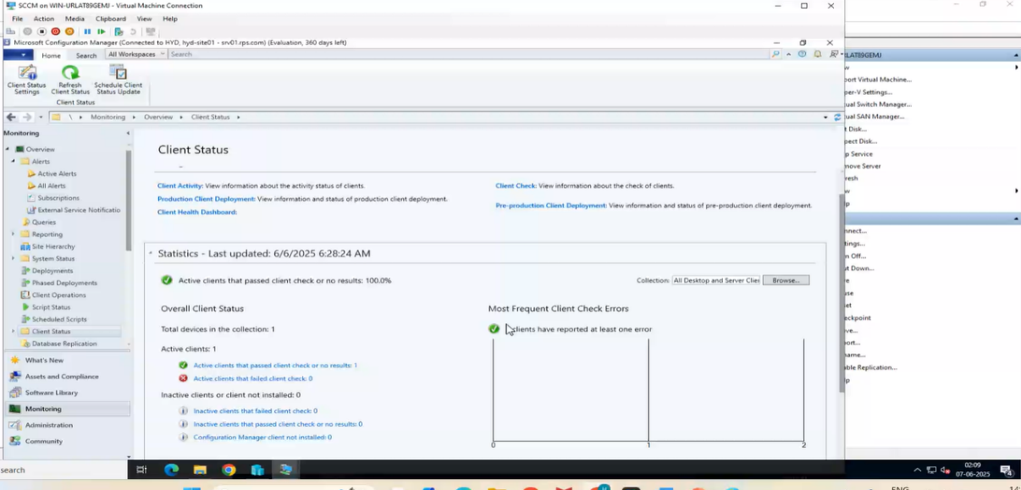**Client Status:**

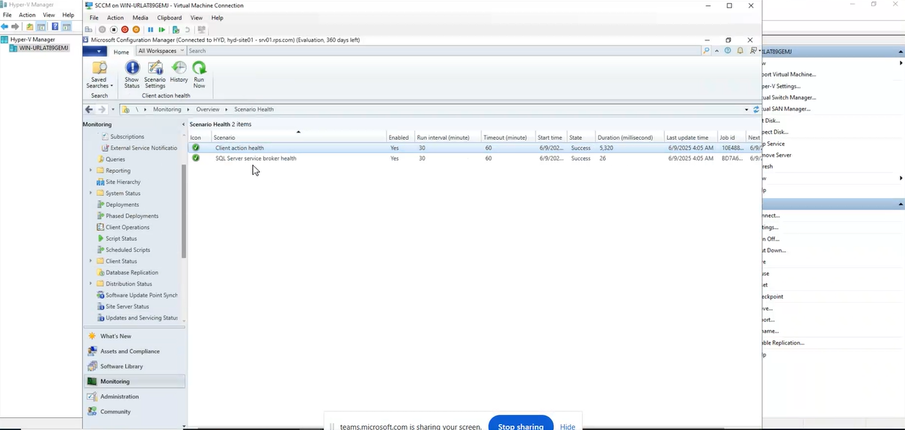**Health:**

**Alert:**

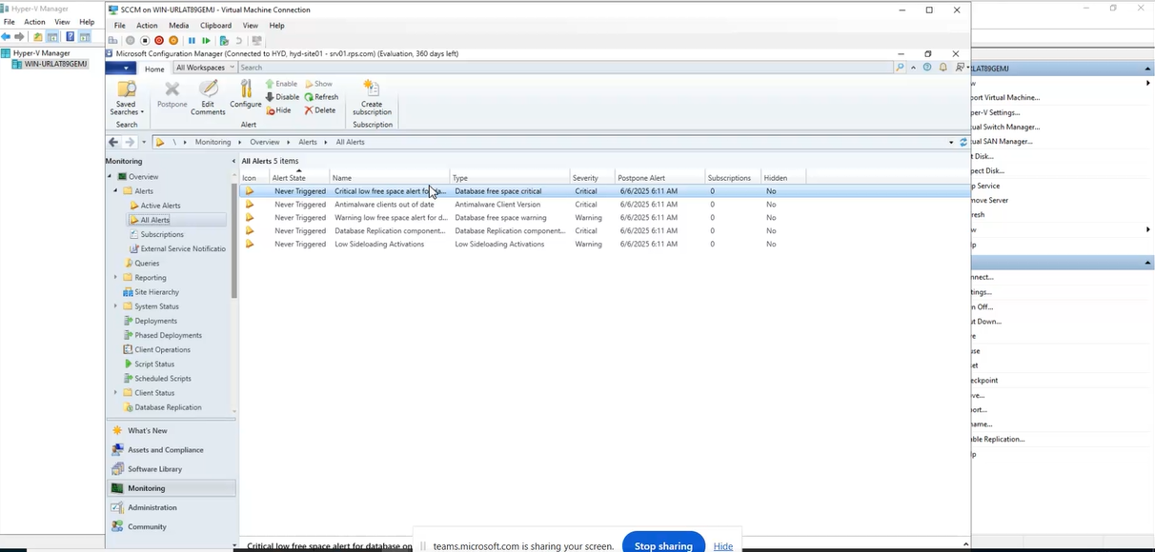

* **Troubleshooting**

In Troubleshooting, fix issues using Software Center, Control Panel, and command-line tools. Client issues like failed installations, updates, or communication.

**Software Center:** Installed on each client, allows users to install apps, view updates, and see device compliance.

**ConfigMgr Control Panel Applet (smscfgrc)**: Use the ConfigMgr client applet to check the client's core configuration, troubleshoot client-related issues.

**Command Line Tools**:Use tools like ccmrepair, ccmsetup, and control smscfgrc for fixing and accessing client settings

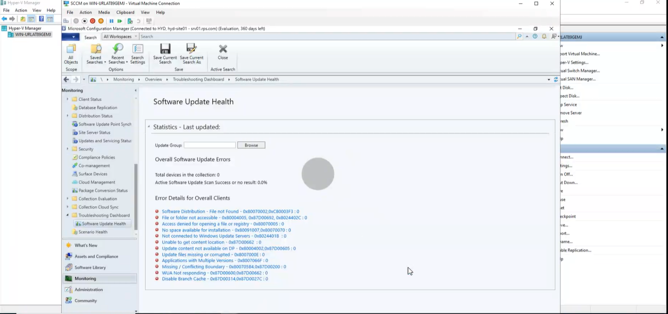**Troubleshooting Dashborad:**

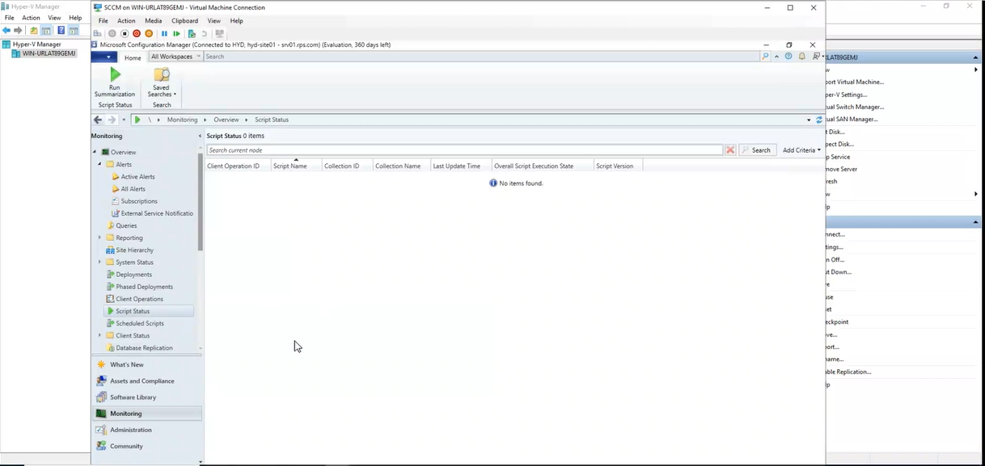**Script Status:** Here the scripts are present and on the top we have **Run Summarization** to run the script